SHOPNEST SALES ANALYSIS REPORT

Capstone Project (Power BI)

Submitted To:
Skillovilla
Submitted By:
Shantu Sharma
Batch: DAP-202509-1

CONTENTS
INTRODUCTION 3
TOP CATEGORIES BY TOTAL PRICE 4
DELAYED ORDERS ANALYSIS 5
MONTHLY COMPARISON OF DELAYED AND ON-TIME ORDERS 6
DRILL-THROUGH ANALYSIS: MONTHLY DELIVERY PERFORMANCE 7
PAYMENT METHOD ANALYSIS 8
PRODUCT RATING ANALYSIS 9
STATE-WISE SALES ANALYSIS 11
SEASONAL SALES PATTERN 12
REVENUE ANALYSIS 13
CONCLUSION 14

INTRODUCTION
ShopNest stands as the leading department store in the e-commerce marketplaces in Portugal, serving as a seamless link connecting small businesses from various regions to online channels. In today's dynamic business environment, the importance of data analytics cannot be overstated, particularly in enhancing decision-making and operational efficiency.
Project Overview:
This project on ShopNest data set analyzes revenue trends, performance of products, customer behaviors, efficiency of delivery and seasonal sales patterns using Power BI. The analysis includes top product categories based on sales performance, numeration of delayed orders, seasonal delivery performance, payment patterns, state-wise sales, product ratings and revenue growth over time. This report provides both simple explanation and analytical insights on the overall business performance of ShopNest.
Goal of the analysis:
The goal of this project is to search thoroughly and carefully for information into ShopNest’s operations with the help of data analytics and analytical tools. This project aims to determine the actionable insights, effective enough to improve the decision-making and operational effectiveness of ShopNest stores. All of the analysis contributes to the understanding of different aspects of ShopNest’s operations behavior and performance as well as uncovers data-driven solution to improve customer satisfaction and business outcomes.

TOP CATEGORIES BY TOTAL PRICE
Question Statement:
Identify and visually represent the top 10 product categories by total sales.
Visualization:
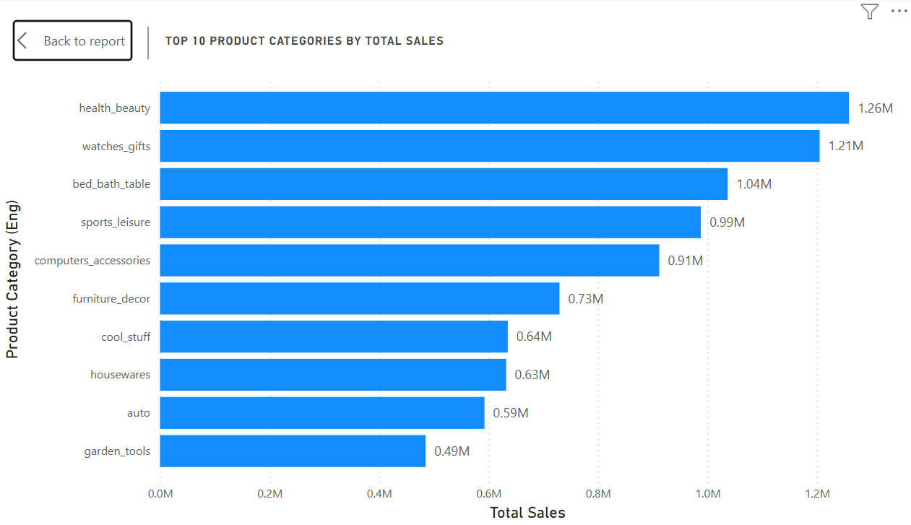
Explanation:
The above visualization depicts the top product categories by total sales. It identifies the pattern of demands of customers based on their preferences; it also reveals the more profitable product categories.
"Health Beauty" leads as the top revenue generator, with 1.26 million in sales, followed by "Watches Gifts" with 1.21 million, while "Bed Bath Table" contribute 1.04 million, making it the third-largest revenue contributor. It is noted that the top 3 product categories each exceed 1 million in sales. These categories dominate customer expenditure and are the ones contributing largely to overall revenue. "Sports Leisure", "Computers accessories", each exceed 0.9 million in sales, followed by "Furniture décor" with meaningful 0.7 million in sales. While "Garden tools" and "auto" product categories perform comparatively lower than others, they generate sales of approximately half a million each, show steady demand. The top 5 categories together generate over 5.4 million indicating concentration of revenue.
For high & low performing categories, inventory management & targeted campaigns can be increased respectively in order to unlock additional potential, especially to the top 3 categories, as they collectively exceed 3.5 million.

DELAYED ORDERS ANALYSIS
Question Statement:
Determine the number of delayed orders in each category. An order is considered delayed if the actual delivery date is later than the estimated delivery date.
Visualization:
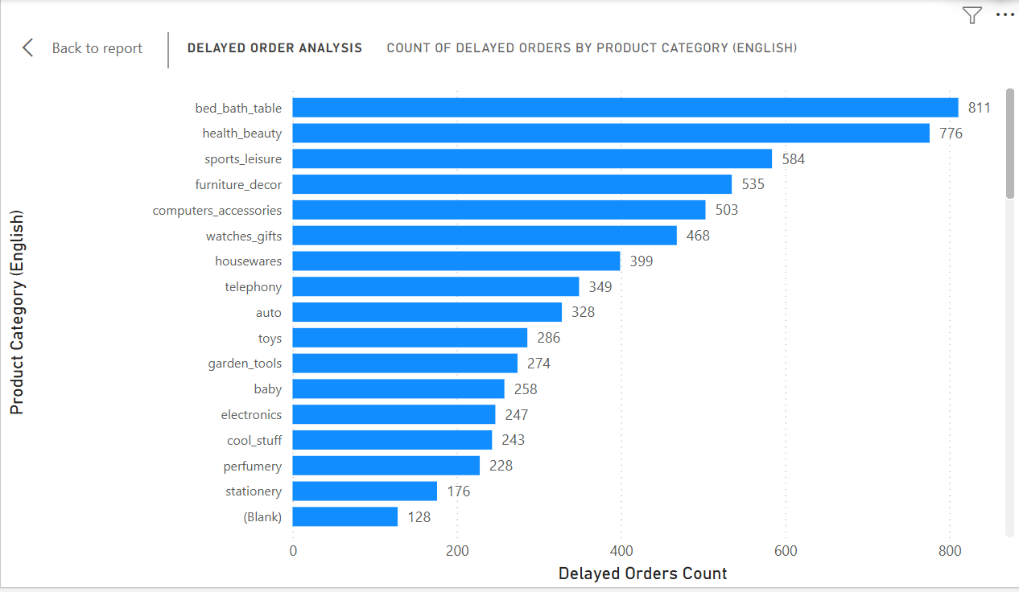
Explanation:
The bar chart displays the total numeration of delayed orders across different product categories, highlighting challenges in logistics related to specific product categories.
“Bed Bath table” and “Health Beauty” experience the most noticeable number of delayed orders of 811, 775 respectively. These categories require focused improvements in operations as large number of delayed orders directly impacts customer satisfaction as well as results in poor post-purchase-experience. There is significant delay in categories such as “Sports Leisure” (584 delayed orders), “Furniture décor” (535 delayed orders), “Computer Accessories” (503 delayed orders) and “Watches Gifts (468 delayed orders)”, indicating broader operational challenges across multiple segments. Lower but notable delays appear in categories such as housewares (399), telephony (349), and auto (328).
The top 5 categories sum up for 3209 delayed orders which clearly indicates that operational bottleneck is present in orders of heavy/bulky items or categories of high demand (deduced by analyzing the chart of total sales by product categories), indicating capacity problem, not demand weakness.

MONTHLY COMPARISON OF DELAYED AND ON-TIME ORDERS
Question Statement:
Create a dynamic visual that compares the number of delayed orders to the number of orders received earlier for each month. Utilize the drill through cross-report feature to provide a detailed analysis of late and on-time deliveries.
Visualization:
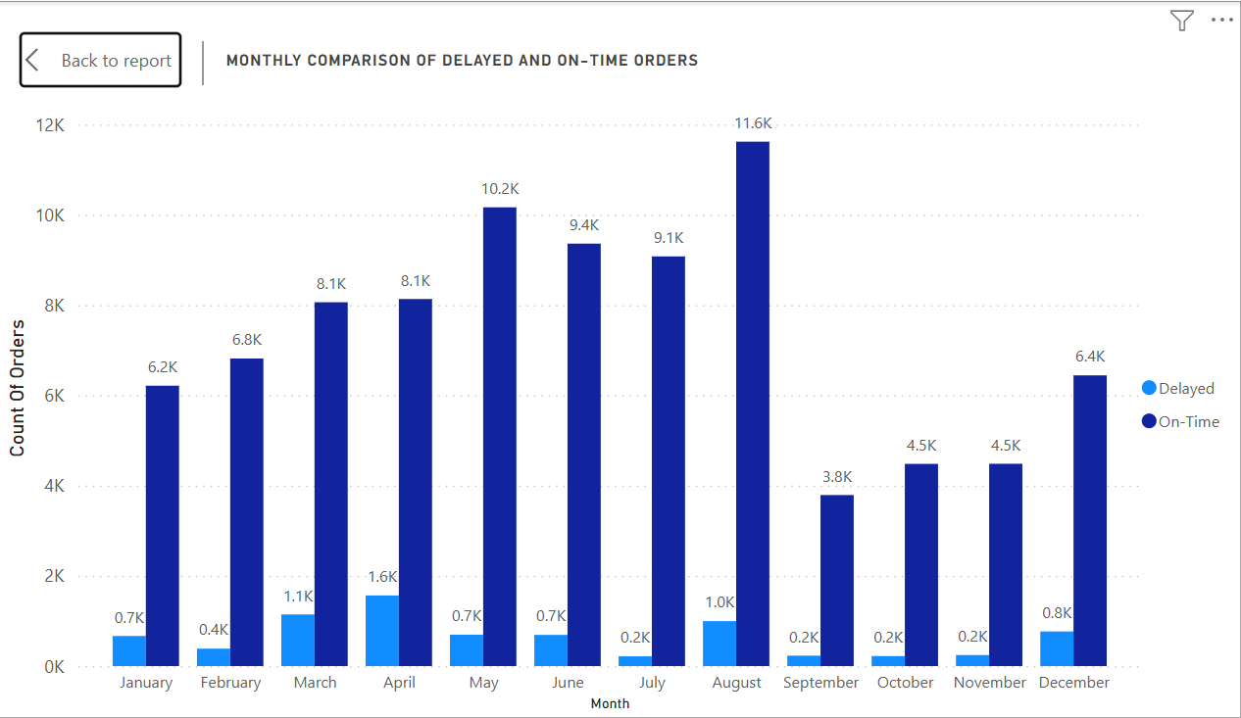
Explanation:
Above is the visualization of delayed and on-time order volume, based on month-by-month comparison, which gives the exact sight of delivery performance trends and highlights months with efficient delivery or high delivery issues.
Orders which are on time are seen throughout the year in high volume ranging approximately from 8.1K to 11.6K, peaking in August with 11.6K "On time" deliveries. Delayed orders oscillate between 200 and 1600. A decrease in the total orders is observed from September to December compared to the first half of the year. The lower numbers of delay in orders are observed in July, September, October and November, near about 200 delayed orders, showing improvement of performance in operation. The delayed in order deliveries spike in March (1.1K) and April (1.6K), likely due to stress in operations and that can be solved easily by temporarily scaling up capacity in during high demand months. However, delayed orders consistently remain below 2K, even during months with high order volume, indicating commendable delivery performance.

DRILL-THROUGH ANALYSIS: MONTHLY DELIVERY PERFORMANCE
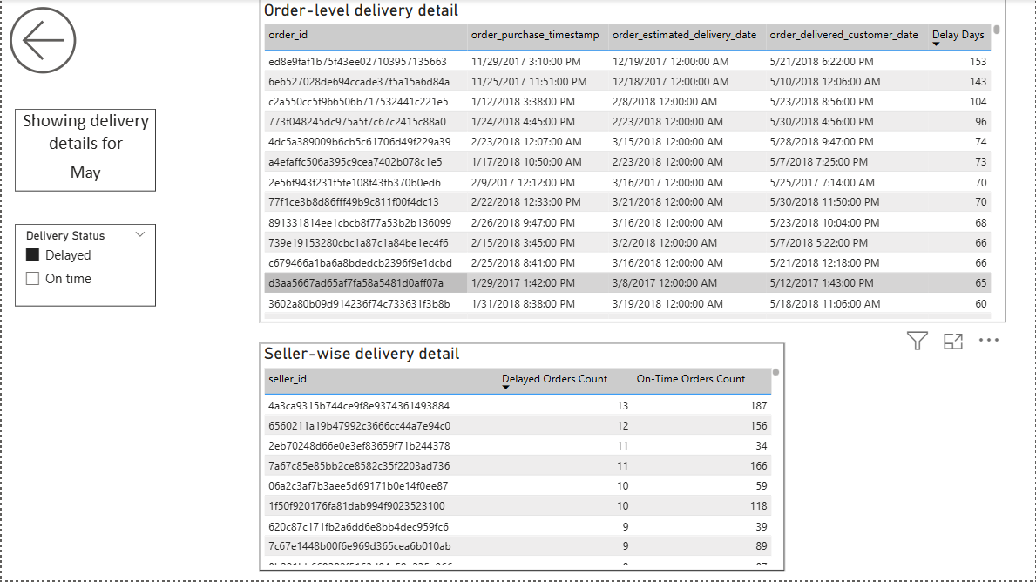
The detailed view using the drill through feature enables to dive deeper into analysing a detailed breakdown of delivery performance on a month-by-month basis. It moves from high-level monthly trend into identifying specific reason behind these monthly trends and answering questions such as; where the delays occur, how severe they are and reveals inefficiency of sellers. The above picture shows two tables:
- Order-level delivery detail: This table shows timestamps for purchase, estimated delivery and actual delivery timestamp along with calculated delay days for each order. This table shows a very impactful insight of severity of delays.
- Seller-wise delivery detail: This shows the number of on-time delivered orders and delayed deliveries by each seller. It helps to determine seller level problems.
For Demonstration: Drill-Through Summary (May)
Most of the deliveries for May were completed on time, some experienced very high delay duration, exceeding 70 days and for some cases, over 100 days. This shows that delay in orders in May is not only affected by numerous small delays, but also by cases with extreme delay duration.
By doing seller-level observation, it is concluded that delayed orders are shared across many sellers rather than only specific sellers. The sellers with highest delays (11 to 13) are also delivering many orders on time, this strongly suggests that delays are likely happening due to large number of orders or delivery issues not due to frequent poor performance by specific sellers.

PAYMENT METHOD ANALYSIS
Question Statement:
Analyze the most frequent used payment methods by customers using a visually appealing representation, such as a pie chart or other suitable visuals.
Visualization:
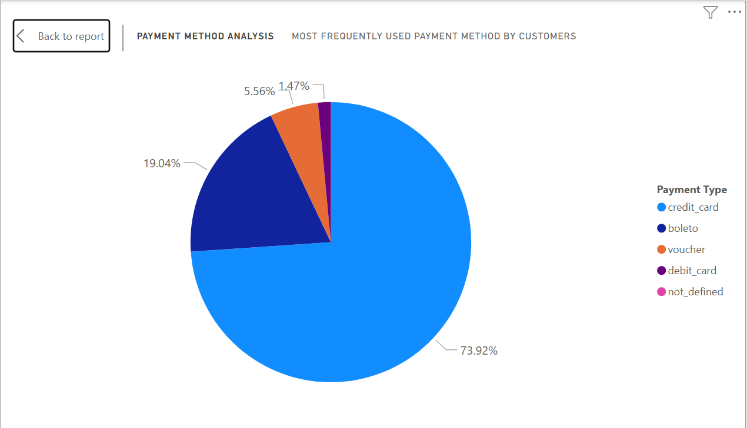
Explanation:
This Pie-Chart analyzes customer payment methods. It shows which payment types such as credit card, debit card, boleto, voucher) customers prefer.
In this chart, it is clearly seen that credit card dominates transaction carried out in ShopNest’s operations by a massive 73.92% (76,795 customers) transactions. Boleto is the second most used method of payment comprising of 19.04% (19,784 customers) among all in transaction of ShopNest’s Operation. Vouchers and debit cards have relatively low user base, 5.56% and 1.47% respectively. Also, it is noticed that most payment method are digital.
This analysis suggests customer have higher trust in credit card payments and it might be because of credit card-based convenience and such as cashbacks and EMIs. Optimizing credit card checkout by partnering up with card networks and issuing card-based discounts would be preferred by customers. Introducing better incentives for underused payment is as vital as improving more frequently used payment method as it can reduce payment risk.

PRODUCT RATING ANALYSIS
Question Statement:
Determine the top 10 highest-rated products and the bottom 10 lowest-rated products using a bar or column chart.
Visualization:
Top 10 Highest Rated Products:
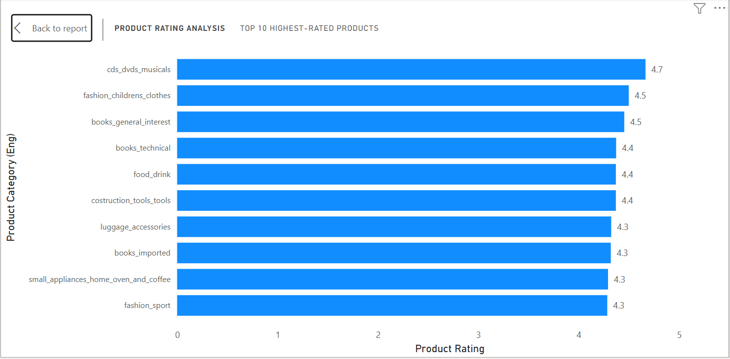
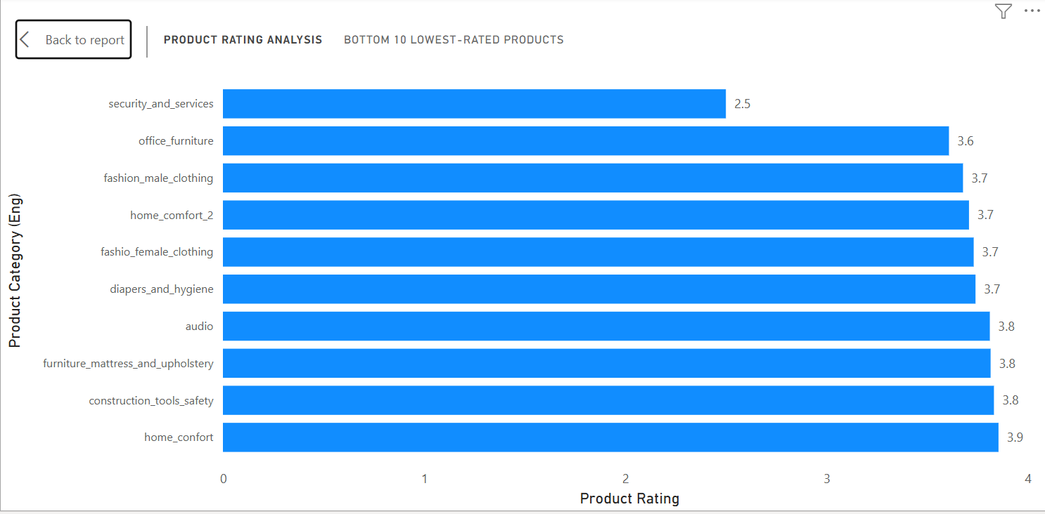
Bottom 10 Lowest Rated Products:
Explanation:
The bar-charts highlight top 10 highest rated products and bottom 10 lowest rated products by customers.
“CDs, DVDs and musicals” tops the list with the highest rating of 4.7, followed by “Fashion children’s clothes” and “Books general interest” with a score of 4.5 each. Other categories such as “Books technical”, “Food & Drink” and “Construction Tools” have a similar rating of 4.4 each suggesting commendable product quality satisfaction among customers. Rest of the categories in this highly rated set have an average rating of 4.3 which shows low variability and customer satisfaction with the product quality, focusing in highlighting these products in marketing campaigns and recommendation can increase brand trust further. Moreover, higher rated products can be restocked confidently since they have established a positive approval rating with customers whereas lower rated products may require quality checks, or removal from the listings entirely to maintain brand trust.
However, the bottom 10 lowest ratings of products categories provide insight into customer dissatisfactions and suggests immediate quality check. The “Security and Services” product category scores the lowest of 2.5 ratings, followed by another low-rated category, “Office Furniture” with a rating of 3.6 indicating significant customer dissatisfaction, which could be a reflection of product reliability or complexity in assembling. “Fashio male Clothing”, “Fashio male clothing”, “Diapers hygiene” and “Home comfort” also underperform with the rating of 3.7 each. Although other product categories in this ranking have recorded a slightly better rating, they all warrant stricter quality check.
Taken collectively, service-based and bulky products show lower satisfaction among customers which indicates issues in relation to installation, handling, or performance of logistics service providers. Immediate actions such as quality control reviews & improvements can be conducted for the low-rated segments.

STATE-WISE SALES ANALYSIS
Question Statement:
Identify and visually represent states with high and low sales, providing a clear understanding of regional sales performance.
Visualization:
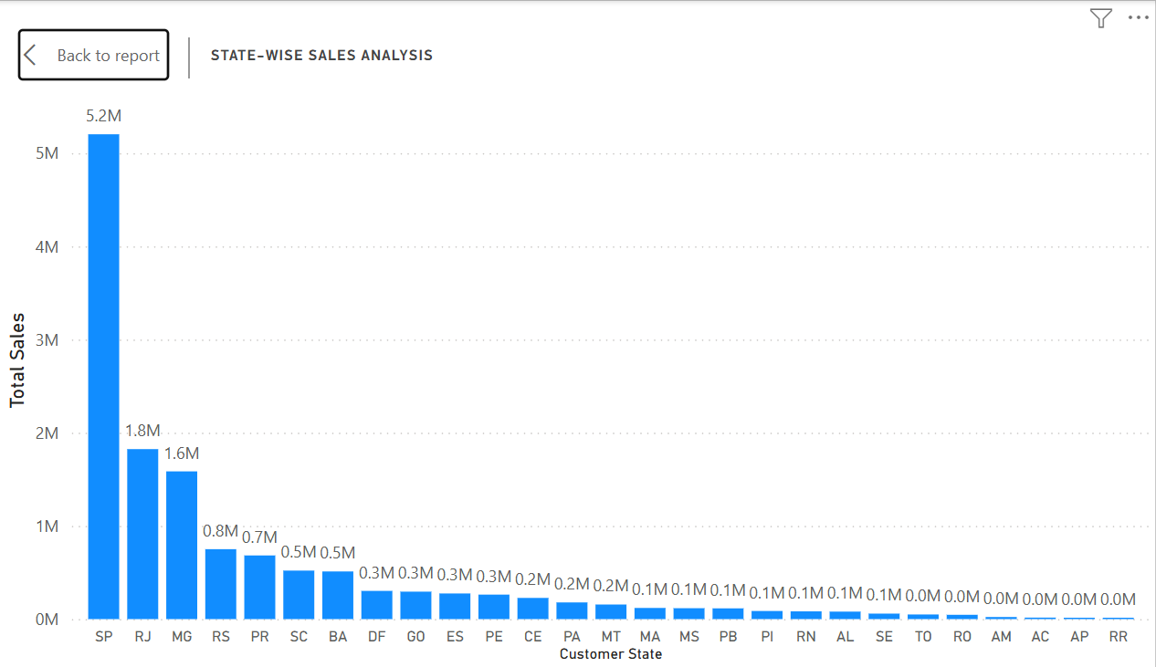
Explanation:
This column chart compares total sales by state.
Sao Paulo (SP) dominates the sales distribution with 5.2 million (nearly 3 times of RJ and covering 38.3% of the total sales) reinforcing it as the strongest regional market of ShopNest. Rio de Janeiro (RJ) and Minas Gerais (MG) follow with sales distributions of 1.8 million and 1.6 million, respectively. These three states share the largest sales distribution combined, thus dominating the revenue contribution. It also shows that Shop Nest’s logistics and marketing are heavily urban-centric. Rio Grande do Sul (RS), Paraná (PR), and Santa Catarina (SC) also show noteworthy sales of 0.8 million, 0.7 million, and 0.5 million, respectively, which shows strong potential for growth. Maranhão (MA), Paraíba (PB), and Mato Grosso do Sul (MS) show low performance sales, which could be due to delivery costs, fewer sellers, or lesser reach of marketing in those areas.
The vast majority of sales is covered by the southeast region approximately 9.9 million sales, highlighting its role as the most industrialized and economically active region, followed by the south region, covering approximately 2 million sales.

SEASONAL SALES PATTERN
Question Statement:
Investigate and visualize any seasonal patterns (Quarterly) or trends in sales data over the course of the year.
Visualization:
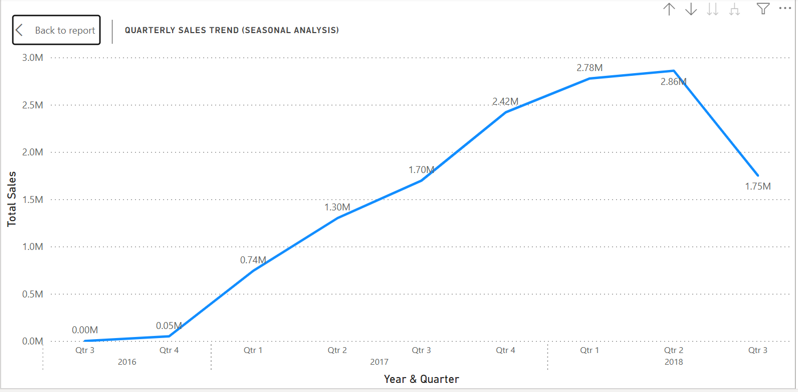
Explanation:
The line chart above displays quarterly sales performance, showing sales fluctuation across season and it also identifies patterns such as peaks and periods of low activity.
Sales is seen to be increasing steadily from the year 2016 to 2018, peaking at the second quarter of 2018. Sales increased from 0.74 million in first quarter of 2017 to 2.86 million in second quarter of 2018, nearly 4 times, indicating rapid expansion of business. A noticeable drop is seen at Q3 of 2018 which may be due to a seasonal or temporary issue. This analysis suggests that Q2 consistently performs better than other quarters, indicating a seasonal increase in sales. During mid-year quarters ShopNest experience strong sales growth. This analysis can be utilized by business in inventory planning, staffing and marketing campaigns more effectively in between high performing quarters in order to generate maximum revenue.
ShopNest can also look for the reasons of sales drop during other quarters and take necessary steps to improve the business operation

REVENUE ANALYSIS
Question Statement:
Determine the total revenue generated by ShopNest Store and analyze how it changes over time (Yearly). Represent this information through suitable visuals to highlight trends and patterns.
Visualization:
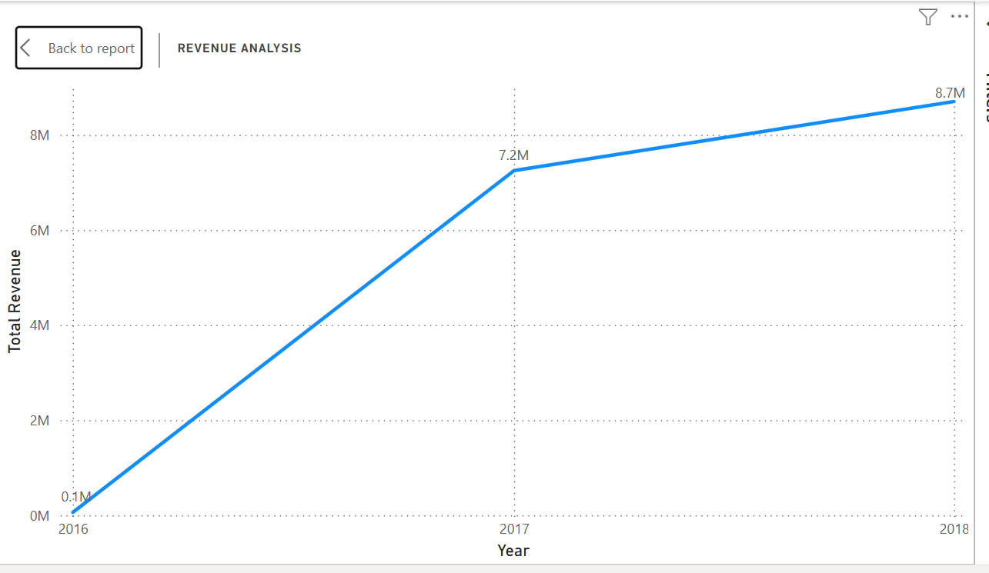
Explanation:
The line charts represent total revenue trends over years; with the help of this visualization, it becomes easier to view the long-term financial performance of ShopNest.
ShopNest’s revenue growth increased sharply from 0.1 million in 2016 to 7.1 million in 2017 and then grew steadily to 8.6 million in 2018, this shows a strong growth over time. Revenue increased near about 70 times during the year 2016 & 2017. This type of sharp growth highlights a breakthrough year in growth of platform and implies large increase in number of customers, product satisfaction and better seller participation. The growth rate compared to 2017 slowed down in 2018 which implies company’s entrances towards more mature stage of growth, it also hints at the stability of business platform.

CONCLUSION
This analysis provides a clear view of ShopNest’s sales performance, product demand, delivery efficiency (along with deep dive), customer behavior, seller performance, and revenue growth using Power BI. Overall, ShopNest shows excellent trends in terms of product categories, sharp revenue generation, level of maturity, and a commendable number of on-time deliveries
The Top 10 list of Product Categories shows that few categories such as “Health Beauty”, “Watches & Gifts,” and “Bed Bath Table”, each generated above 1 million sales, and that’s a remarkable achievement. These categories also show up in “Delayed Orders” analysis, Bed Bath table” and “Health Beauty” with number of delayed orders of 811, 775 respectively, indicating these are of high demands and unable to keep up with it. Thus, it can be concluded that the major factor of delay of these categories is volume not performance.
“Monthly Comparison of Delayed and On-Time Orders” analysis show that on-time deliveries remained at a high level, peaking in August (11.6K on-time deliveries). Delayed orders peaked during March and April which corresponds with higher order numbers, indicating operational pressure during these months. Drill-through analysis shows severity of delays, seller performance and establishes the fact that delayed orders are also influenced by few extremely delayed deliveries.
Payment Method analysis shows that customers use digital payments more and prefer doing transactions using credit card (73.92% transactions) more than other payment methods. There is also room for other categories to be improved and reduce payment risk.
The Product Rating analysis brings quality perspective to these results. High-rated categories, CDs & DVDs, Books, and Fashion Children’s Clothing, show commendable level of customer satisfaction and a high possibility of re-purchase. On the other side, product categories with a lower rating, especially those which are service-oriented or bulky do raise quality and satisfaction concerns which can affect future long-term revenue.
State-wise sales bring geographical picture to the analysis, highlighting best and worst performing states, due to convenience disparity. ShopNest’s operations have clustered financial performance in southeast region states, such as São Paulo with 5.2M revenue sales, followed by Rio de Janeiro with 1.8M and Minas Gerais with 1.6M. ShopNest’s operation are urban centric and lot of room for improvement in low performing states, by increasing marketing reach via multiple mediums.
Lastly, based on both the revenue and seasonal trend analysis, it can be observed that ShopNest indeed grew very quickly in terms of revenue (2016-2018), rising from 0.1 million to 8.7 million. Although growth has slowed, slower growth rate in latter stage indicates ShopNest’s transition to mature stage and stability where efficiency of delivery and product quality plays an important role to grow further.
Final Conclusion:
ShopNest’s operation is mainly concentrated in specific regions and shortlist of categories, with excellent revenue growth, along with commendable delivery timings and product quality which have a huge role in growth at latter years. As per the analysis of dataset, it can be concluded that ShopNest do face challenges of capacity scaling, logistics inefficiency and product quality in other segments, ShopNest need to factor an increased volume of sales, better delivery performance, include convenience in payment methods, geographic expansion, increasing marketing and its reach and improved product quality to maintain trust and achieve future success.

